Derrick Fox

CS 136

July 5, 2014

Week 6

Week 6

1. Identify possible use cases and actors, and create a use case diagram for the Personal Trainer information system.

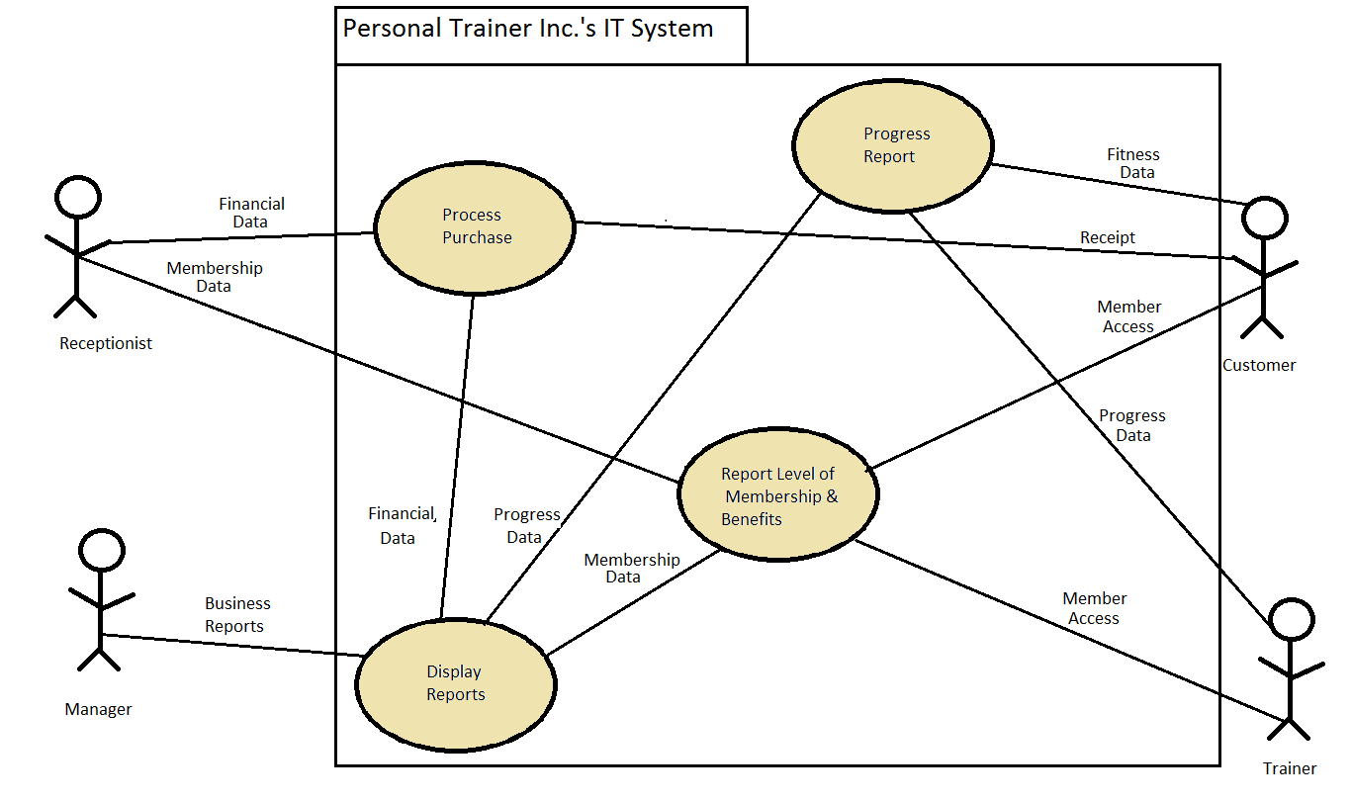

2. Select one of the use cases and create a class diagram.

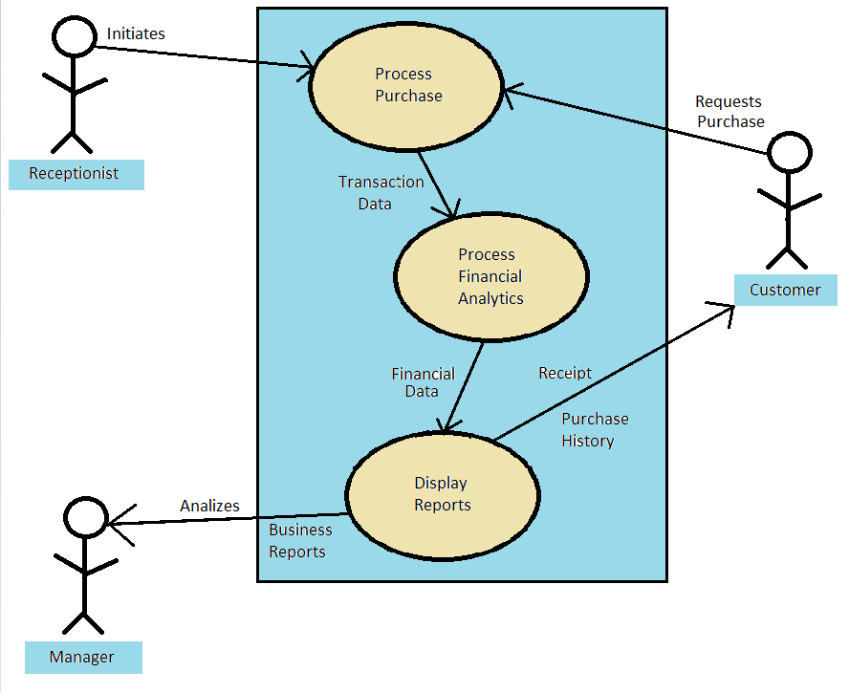

3. Create an object relationship diagram for the system.

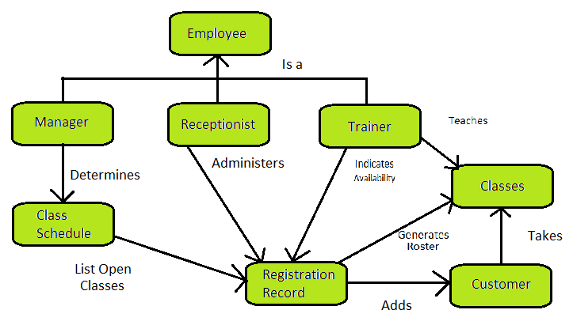

4. Create a state transition diagram that describes typical member states and how they change based on specific actions and events.

